# AMIS SIG – Low Code development with VBCS

September 2018

In this workshop you will experience Low Code development with Oracle Autonomous Visual Builder (Cloud Service). You will create a Business Object by simply dragging and dropping an Excel file. You will create an application with the created Business Object. You will explore the things VBCS creates for you. You will create an editable table, which requires just a bit of code.

In this SIG you get a rough idea what VBCS can do and what it feels like. Hopefully it will make some of you curious !

Starting VBCS

In this SIG you can use the [herman.mensinga@gmail.com](mailto:herman.mensinga@gmail.com) Trial account. But there is no problem in creating your own trial via <https://myservices.us.oraclecloud.com/mycloud/signup>

<https://visualbuilderhmensingqsvb-hmensing.builder.ocp.oraclecloud.com/ic/builder/>

[herman.mensinga@gmail.com](mailto:herman.mensinga@gmail.com)

VBCSSIG25sept

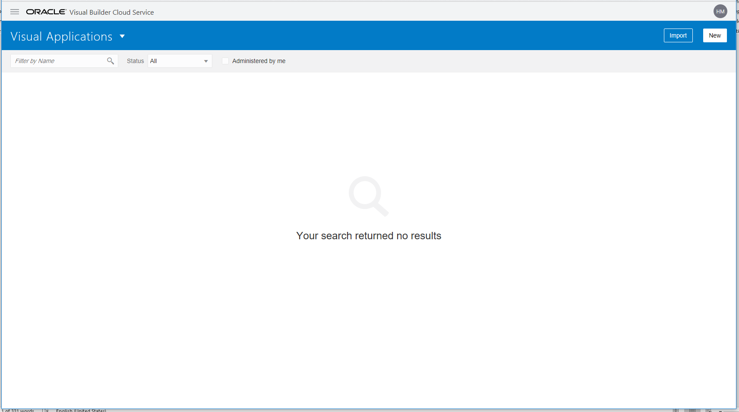

### Create Application

Create an application containing your own name.

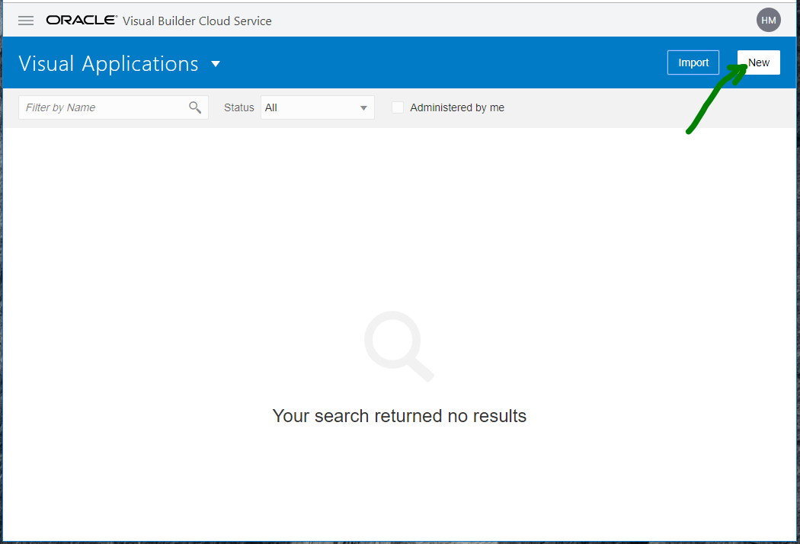

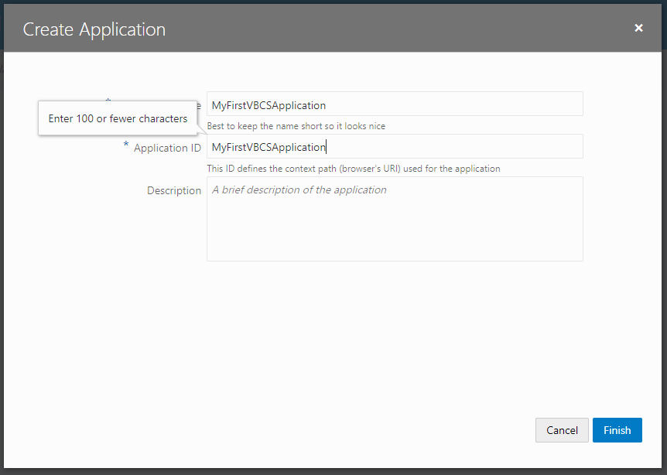

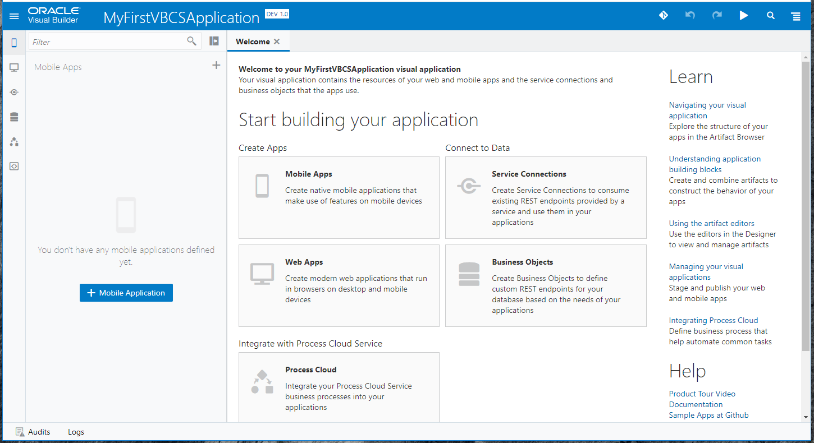

### Create Business Object

We will create two Business Objects from one Excel-file.

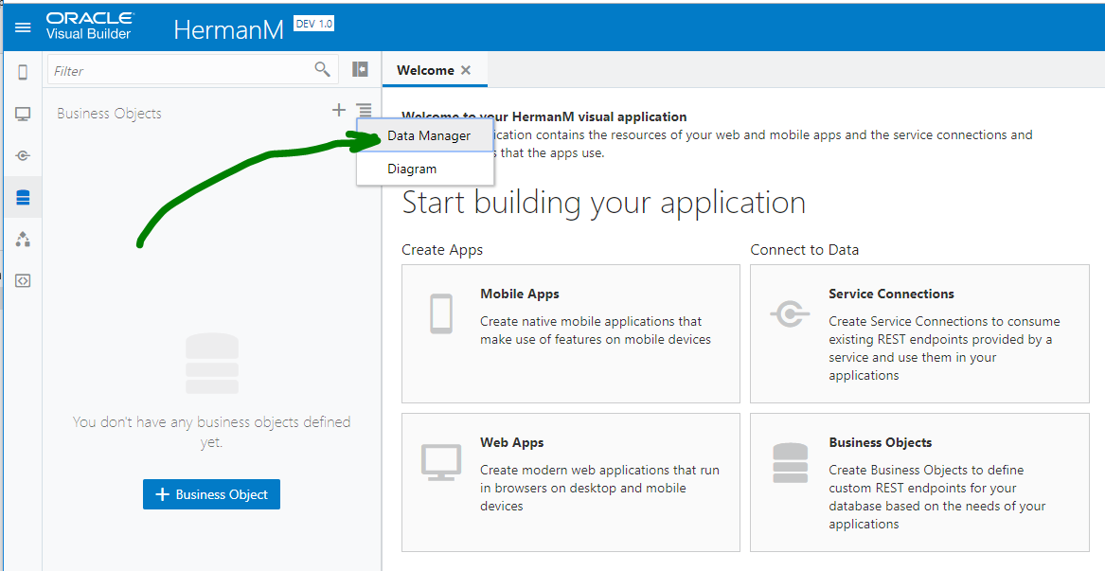

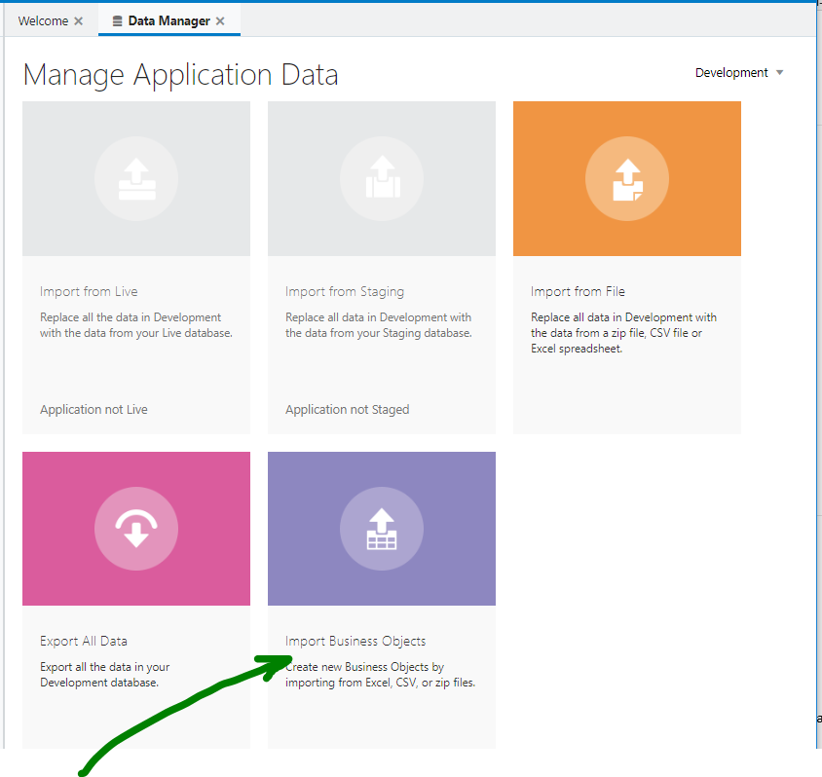

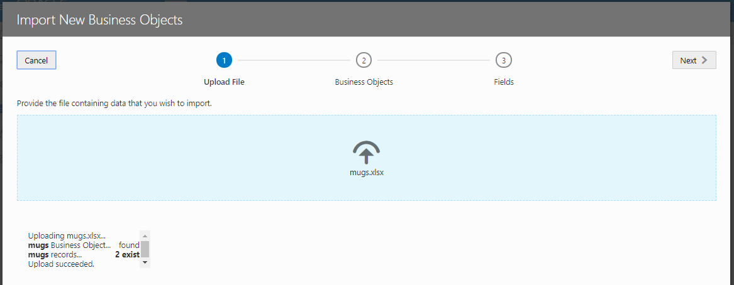

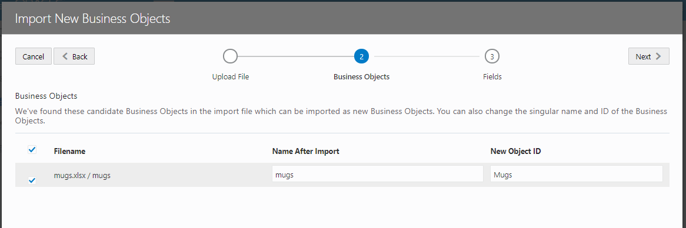

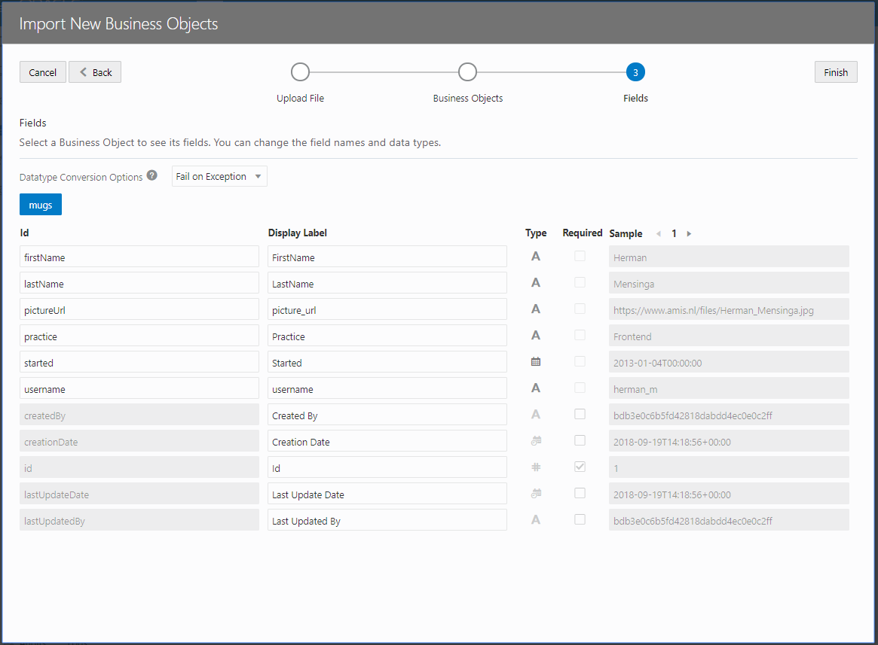

Validate the created BO

Link the two BOs

### Create a Web Application

We could also create a Mobile Application, but for this SIG creating a Web Application is quicker and gives us enough opportunities to explore some of the concepts.

#### Create the overview page

…

Also explore what has been created:

* Variables
* HTML
* Javascript

#### Add a detail page

…

Also explore what has been created:

* Variables
* HTML
* Javascript

Add the create and edit page

…

What is this ETag doing ?

Use a REST API/interface

We will make use of the REST Countries REST API, https://restcountries.eu/rest/v2/

#### Create an LOV

JHipster provides a [Chocolatey](https://chocolatey.org/) package, available on <https://chocolatey.org/packages/jhipster>.

To install JHipster (as well as Node, Yarn, Yeoman, Java and Git), just type:

Show flag for favourite country

Also install docker: choco docker-for-windows

Create an editable table

We will make use of the REST Countries REST API, https://restcountries.eu/rest/v2/

#### Create an LOV

JHipster provides a [Chocolatey](https://chocolatey.org/) package, available on <https://chocolatey.org/packages/jhipster>.

To install JHipster (as well as Node, Yarn, Yeoman, Java and Git), just type:

Show flag for favourite country

Also install docker: choco docker-for-windows

## Sign up for a trial account

<https://myservices.us.oraclecloud.com/mycloud/signup>

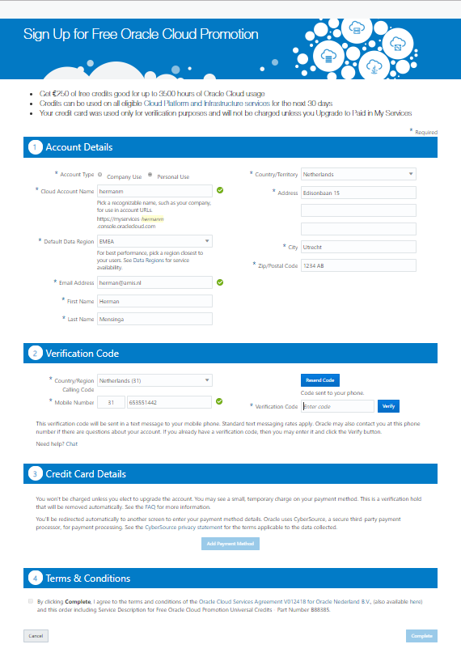

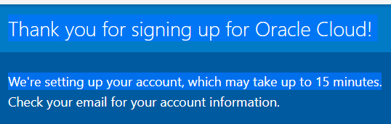

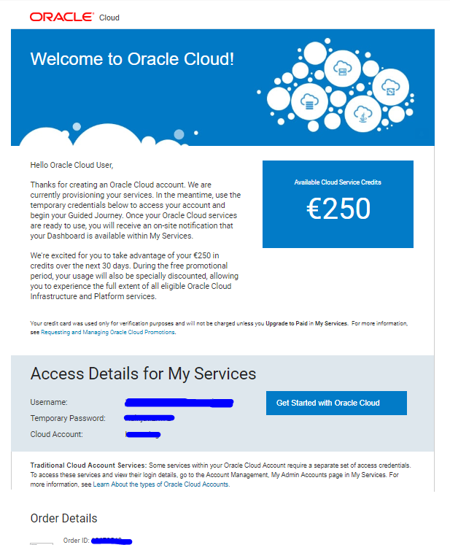

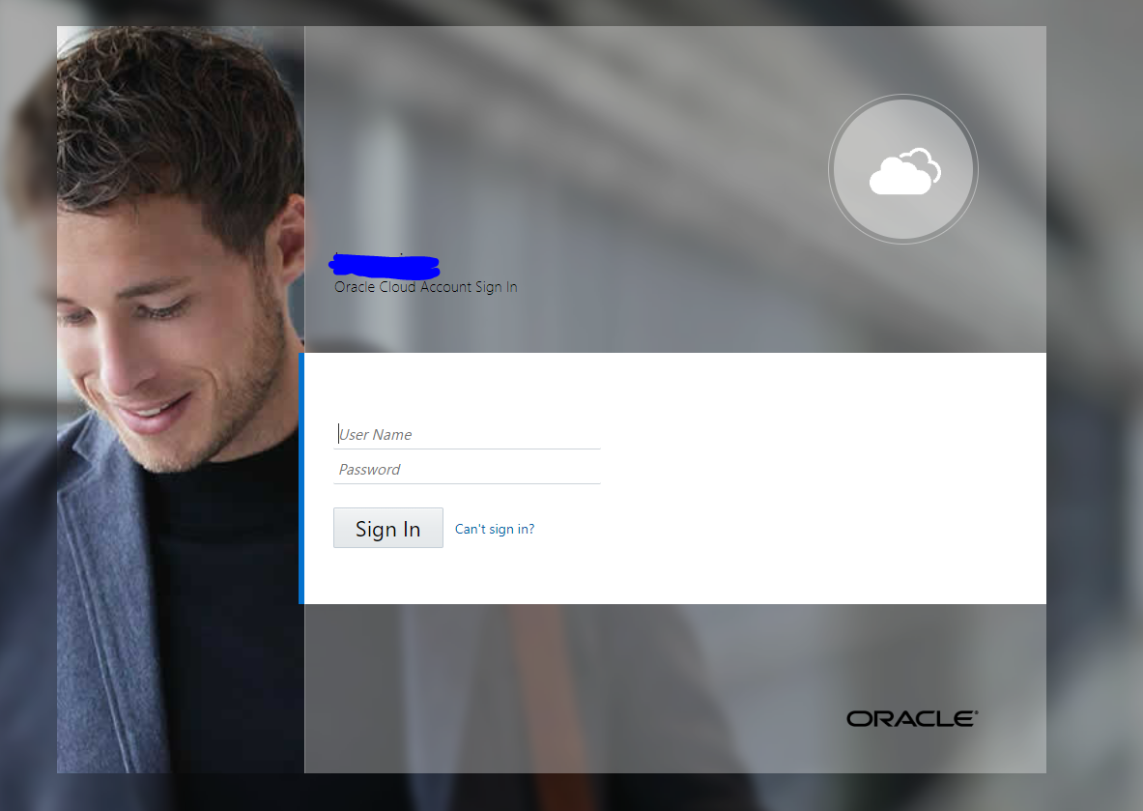

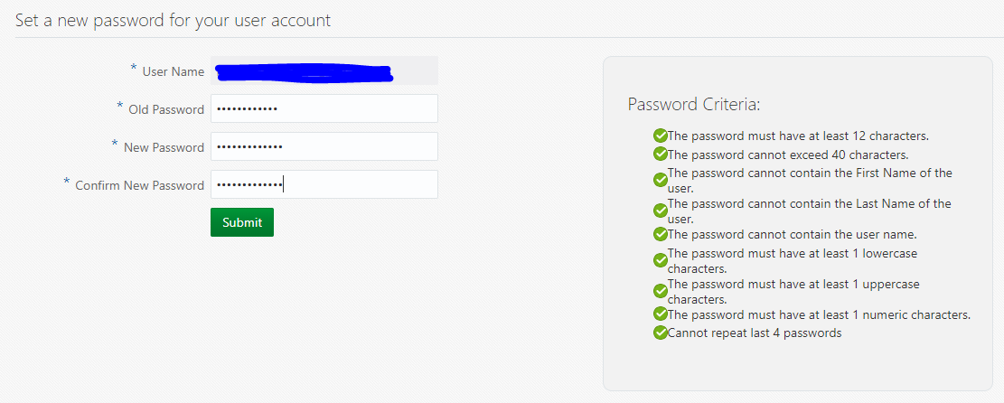

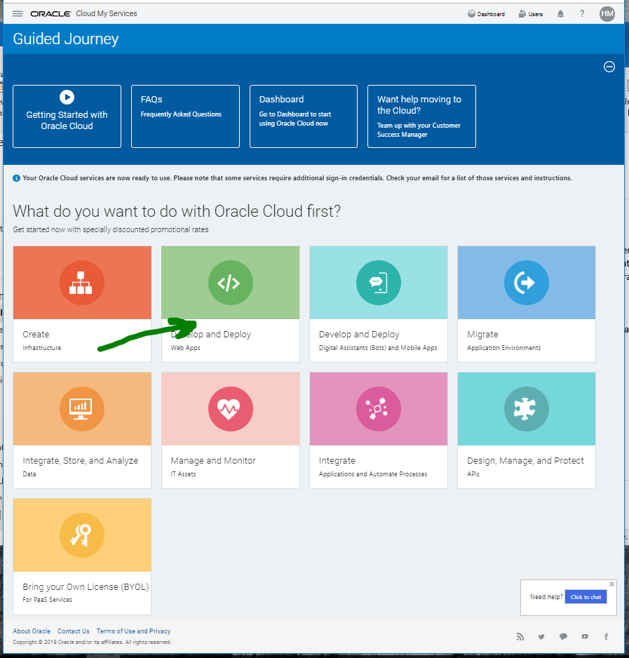

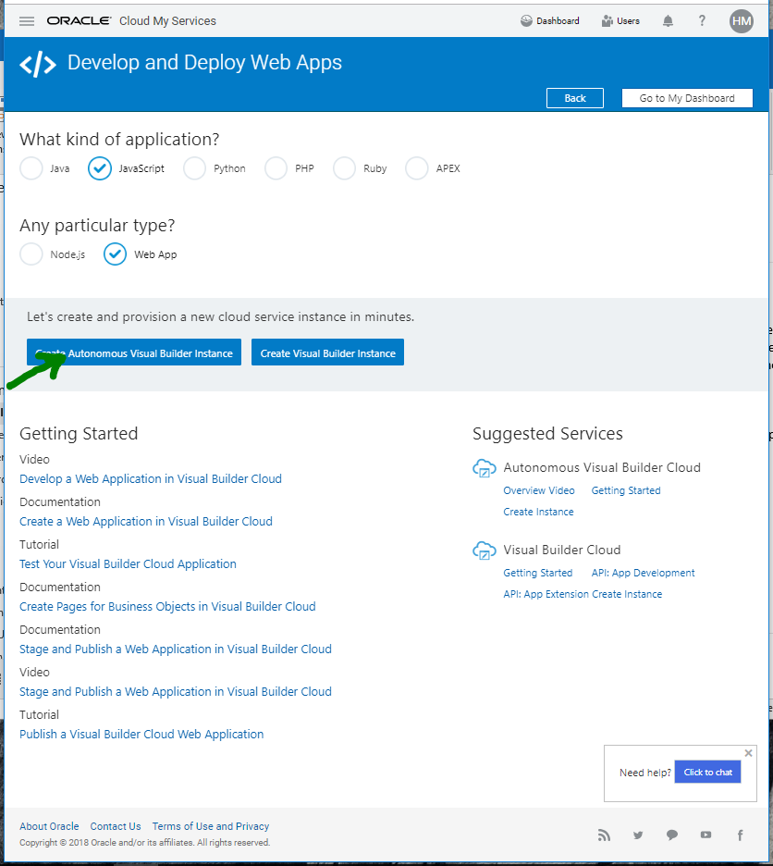

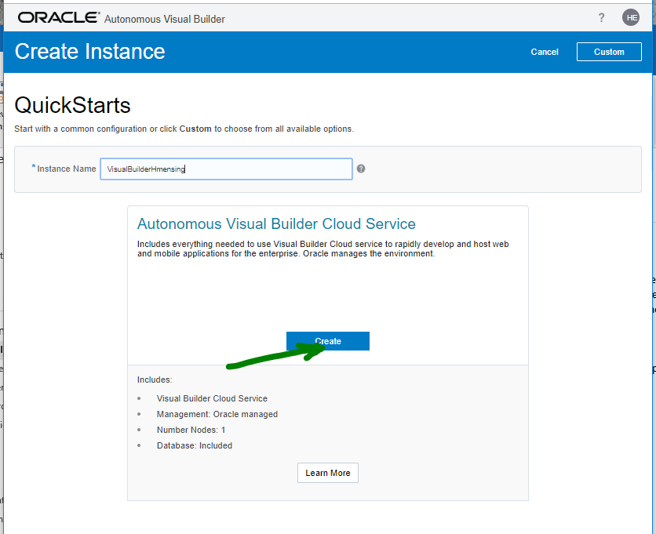

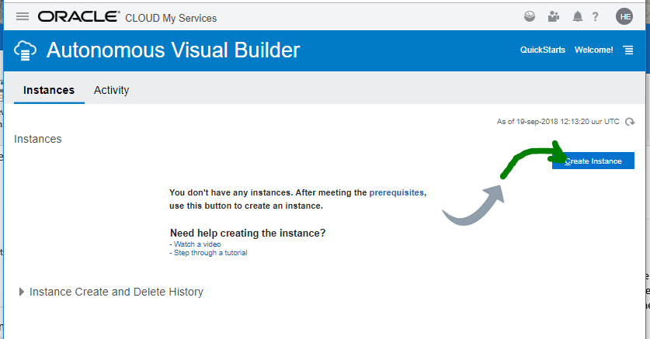

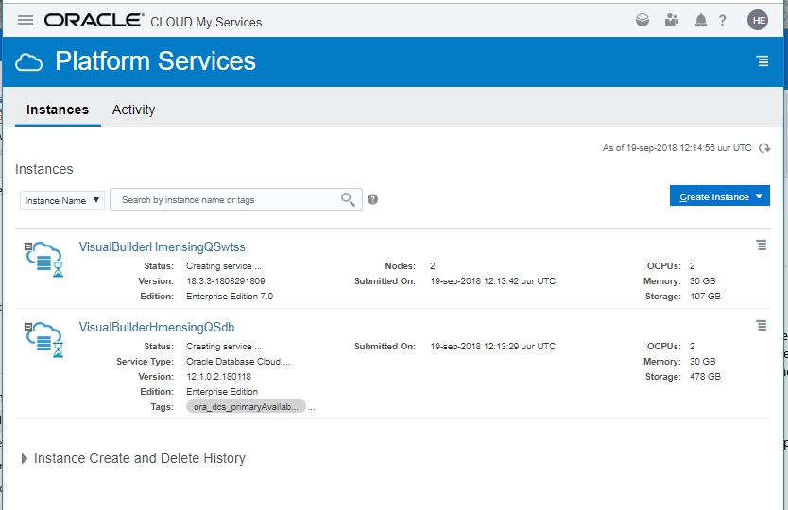

This takes 15 minutes

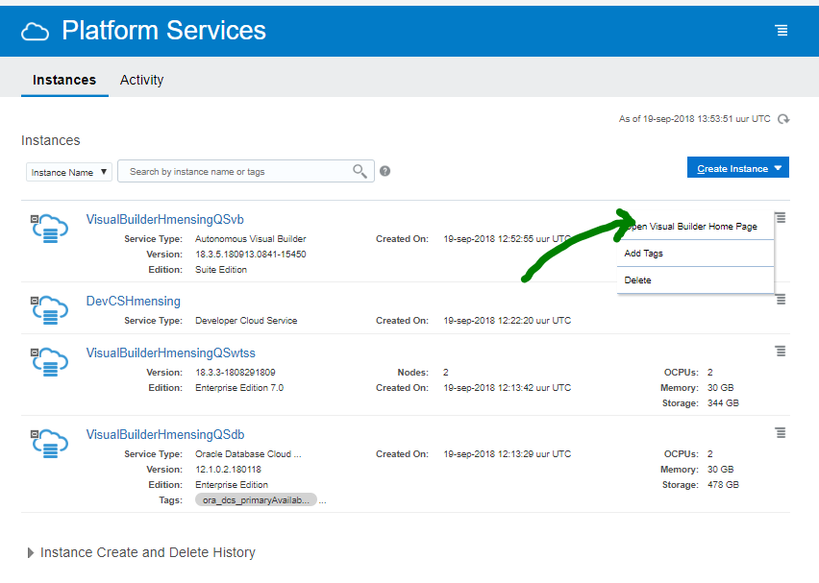

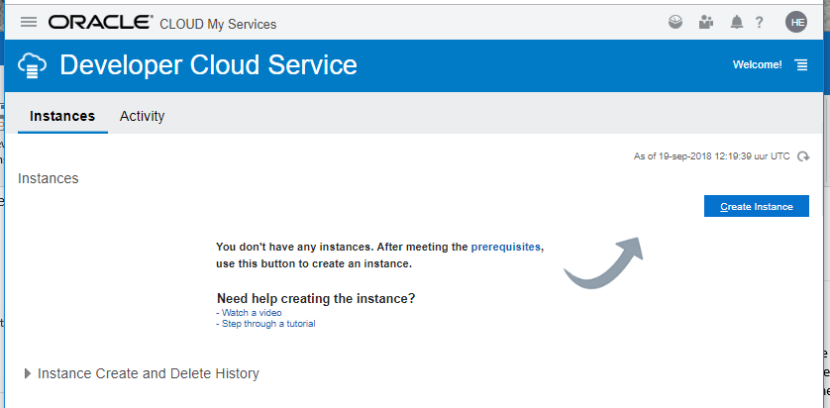

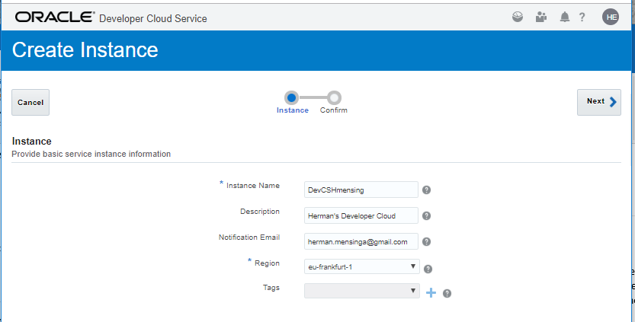

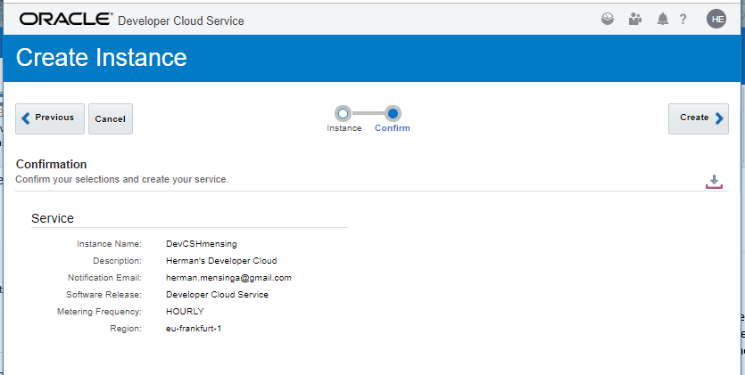

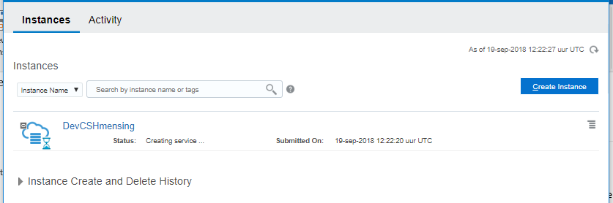

Mail

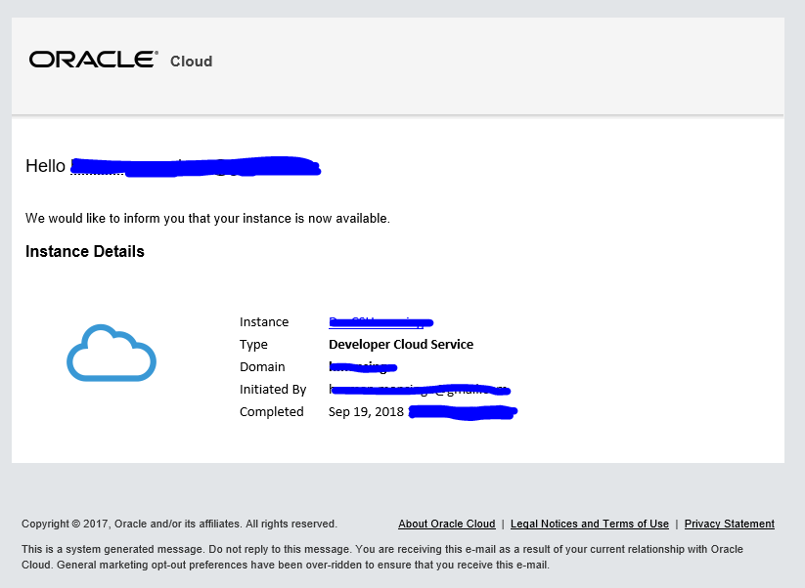

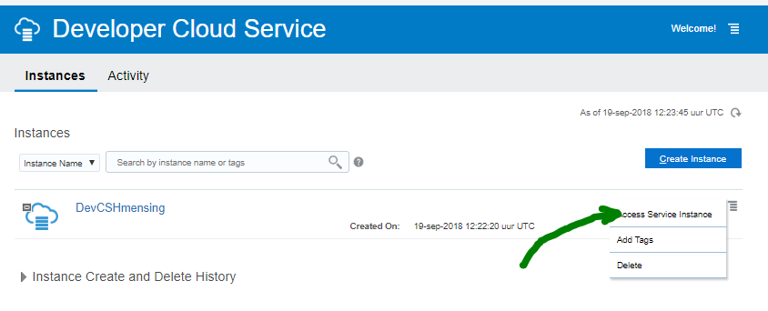

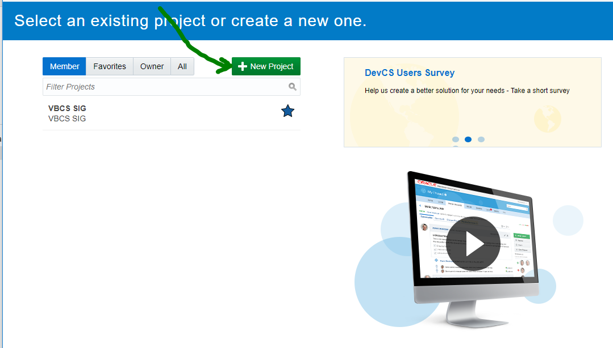

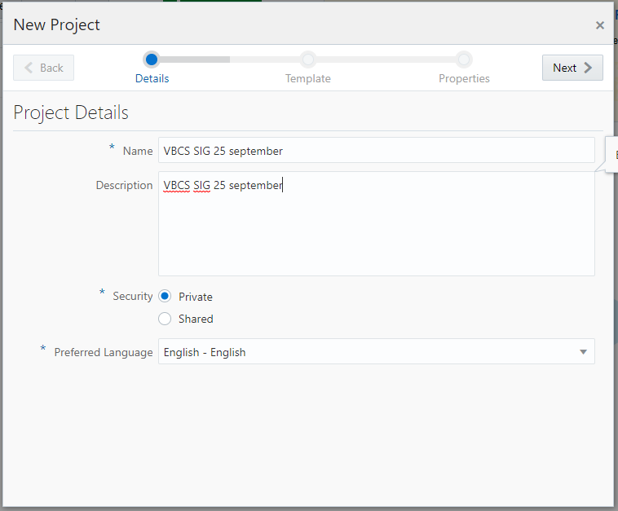

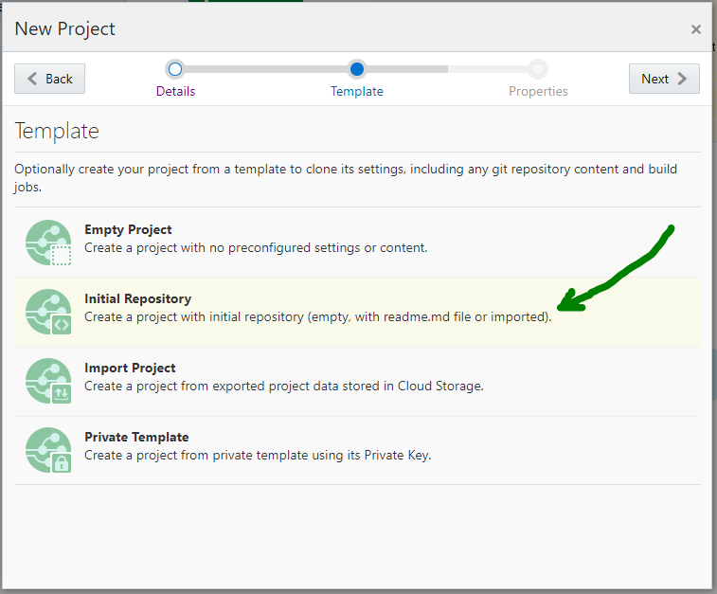

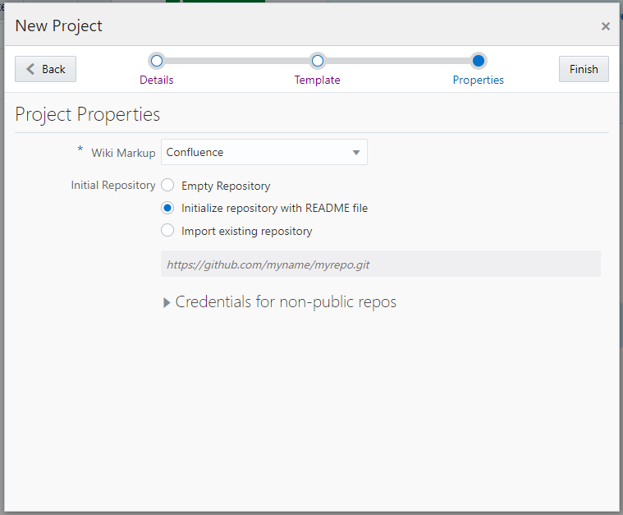

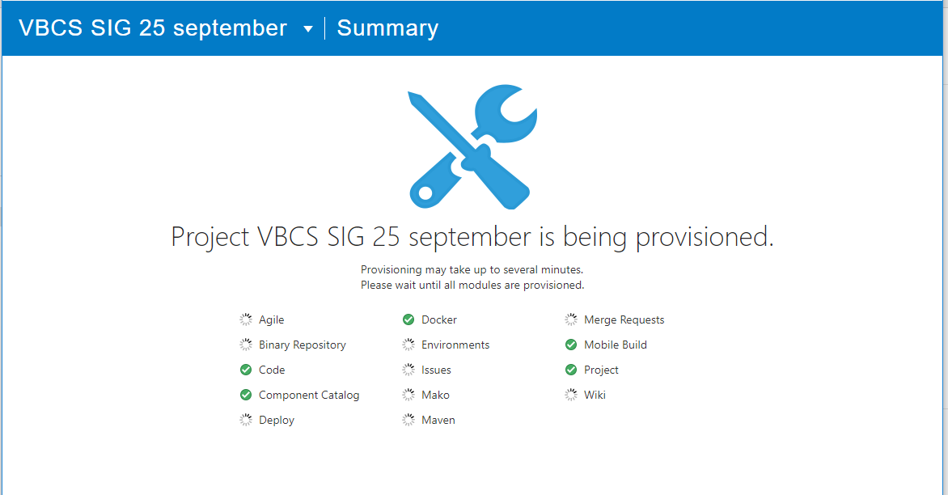

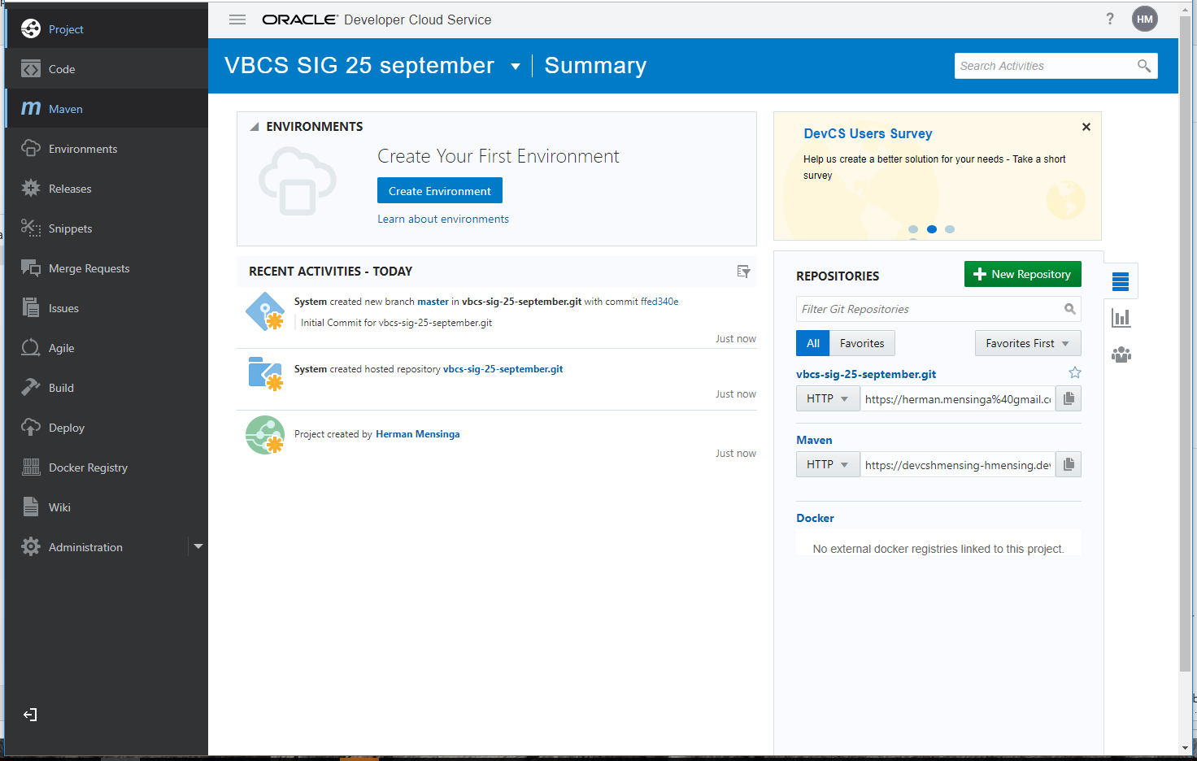

Clone it like you do normally 😊